**D-Crypt Installation Guide**

*by Ko Jia Ling*

# Programs/Modules Required

* Python (python-3.7.0-amd64.exe) ([Download here](https://www.python.org/downloads/release/python-370/))
* PyCryptodome (version 3.9.7)
* Flask (version 1.1.2)
* WTForms (version 2.3.9)

# Table of Content

Programs/Modules Required 1

Table of Content 1

Installing Python 2

Downloading of D-Crypt Files 3

Installing Python Modules 4

Starting the Application 6

# Installing Python

1. Download and install the correct version of Python (v 3.7.0) from [here](https://www.python.org/downloads/release/python-370/). Note: Please ensure that you have installed the correct version of Python for compatibility.
2. Open the installer and click "Install now”.

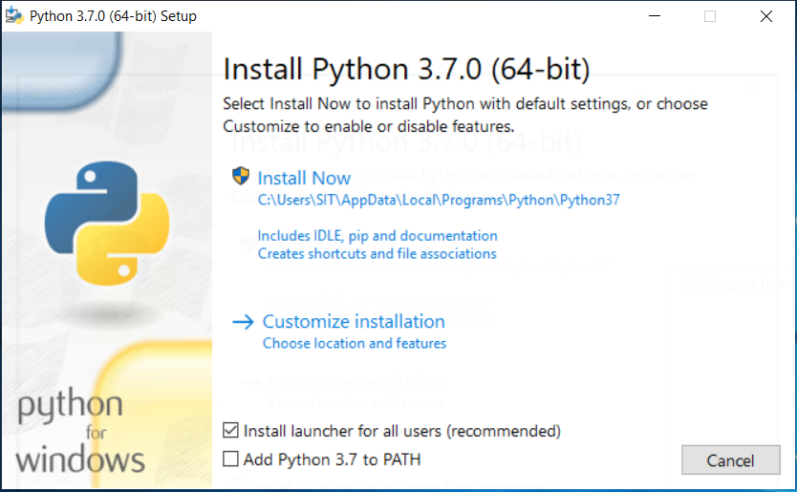

1. Wait for the installation to finish. Upon successful setup, click “Close”.

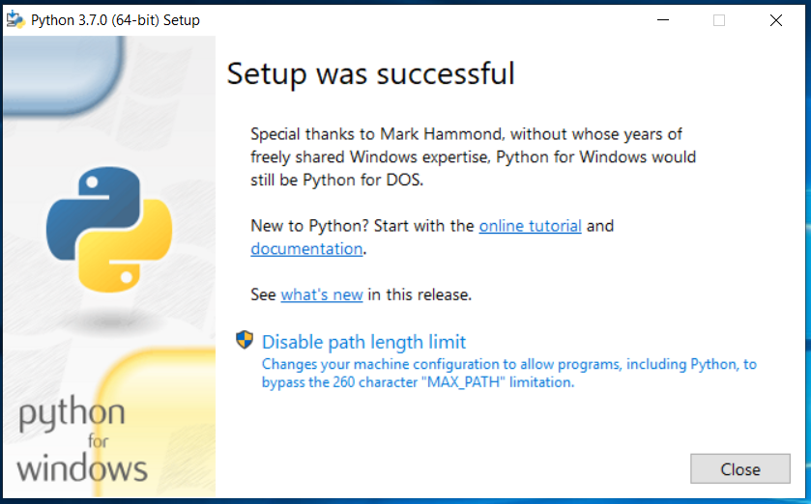

# Downloading of D-Crypt Files

1. Open a browser and visit <https://github.com/Kobot7/D-Crypt>.
2. Click “Clone or download”, then “Download ZIP”.

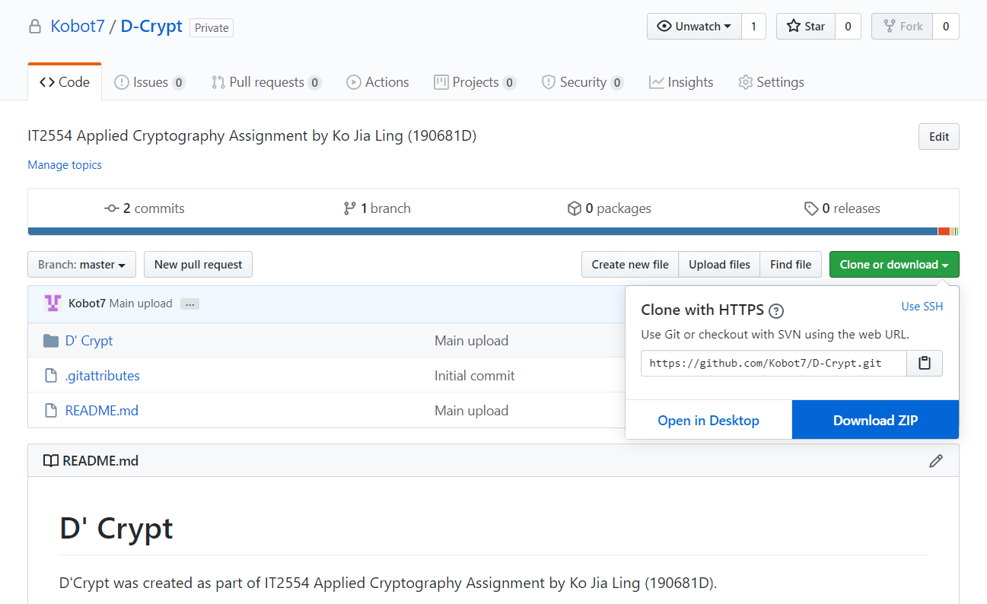

1. Unzip the downloaded file.

# Installing Python Modules

1. Open Command Prompt by searching for “cmd” or “command prompt”.

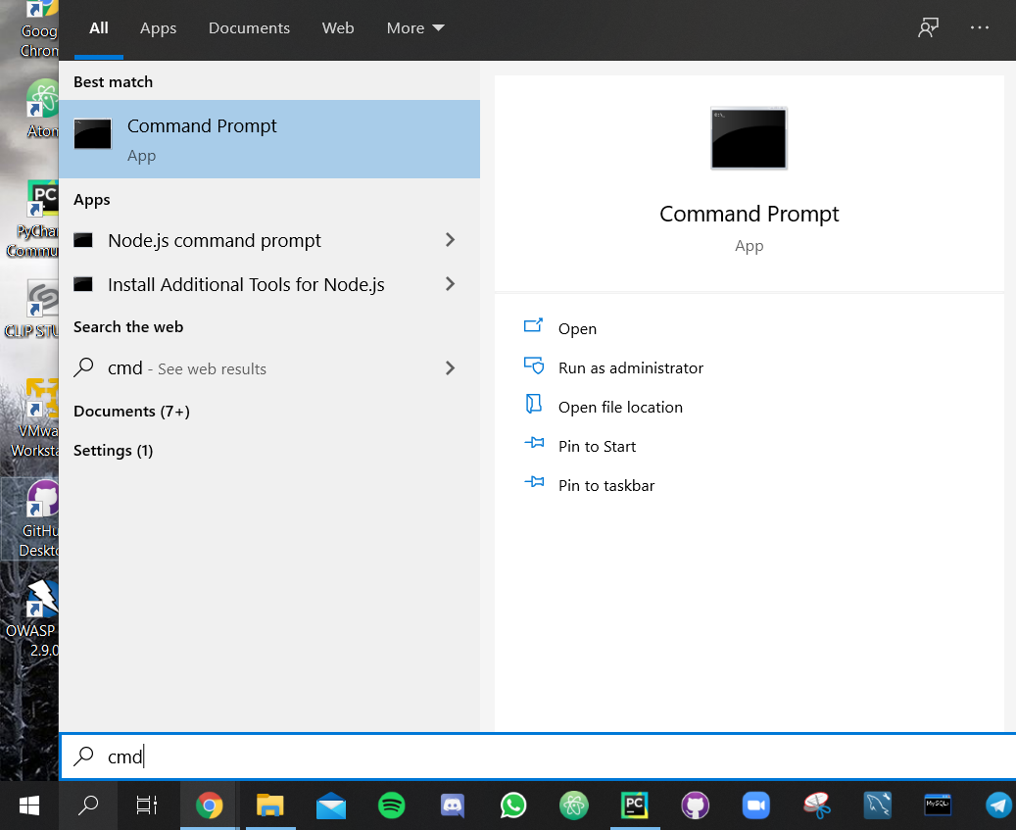

1. Use the change directory (cd) command to navigate to the folder where you downloaded the application.

Open File Explorer and navigate to the place that you saved the application folder. From the breadcrumb, you can determine the path to the project. In this example, the path will be C:\Users\Jialing\Documents\GitHub\D-Crypt

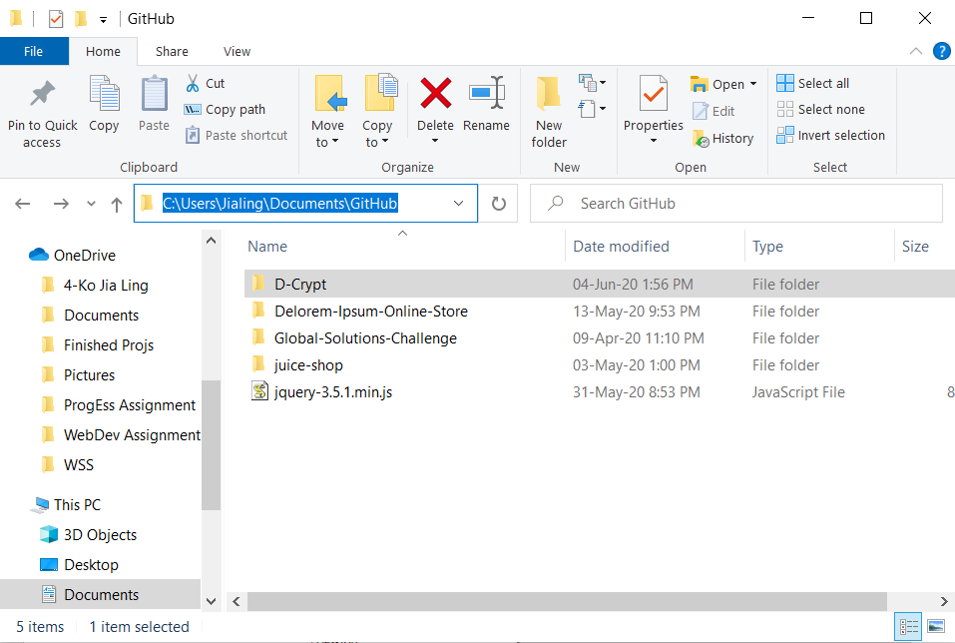

1. Enter the command “cd [insert path here]” into the command line. There should be a change in the path at the start of each line.

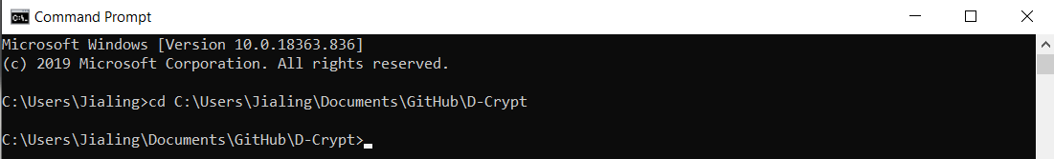

1. Run the following commands:

pip install Flask

pip install WTForms

pip install PyCryptodome

# Starting the Application

1. Open Command Prompt by searching for “cmd” or “command prompt”.



1. Use the change directory (cd) command to navigate to the folder where you downloaded the application.

Open File Explorer and navigate to the place that you saved the application folder. From the breadcrumb, you can determine the path to the project. In this example, the path will be C:\Users\Jialing\Documents\GitHub\D-Crypt



1. Enter the command “cd [insert path here]” into the command line. There should be a change in the path at the start of each line.



1. Run D-Crypt main.py by using the command python D-Crypt/main.py. You should see the following message in the console.

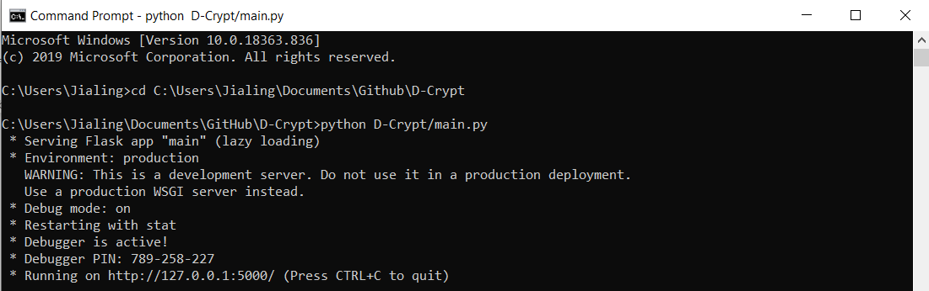

1. Open a browser and visit <http://127.0.0.1:5000/>